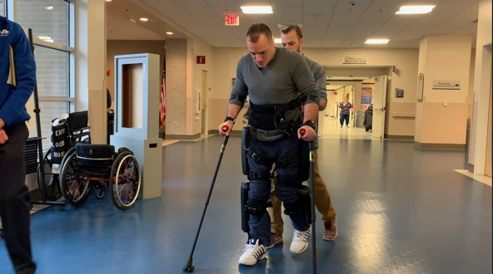
Veteran Walks With Use of Exoskeleton at Milwaukee VA
By Megan Hedstrom Wisconsin
PUBLISHED 4:31 PM ET Feb. 25, 2020

MILWAUKEE (SPECTRUM NEWS)— A Navy Veteran from Wisconsin is making incredible strides thanks to the Milwaukee VA.

James Veltri started his Tuesday by brushing his teeth and saying goodbye to his adorable cat. He headed out the door for one of his weekly appointments at the Milwaukee VA.
"I'm going to do physical therapy with the exoskeleton suit, which assists me walking," Navy Veteran, James Veltri said.

While James drives his car, you would never notice he is driving without using his feet. He is actually using his hands to push the gas and the break. He must drive like this because he is in a wheelchair.
James was able to walk up until 2005, when he tried to break up a fight and was shot in the back. Since then, he has been in a wheel chair. His lifestyle changed and so did his mindset, for the worse. However, a connection with the Milwaukee VA has allowed him to get a spark back into his life.
James comes in once a week to work on walking with an exoskeleton to help improve his independence.
"It feels pretty easy; I definitely don't feel as nervous as the first time. It has gotten a lot easier," Veltri said.

It's hard work and he breaks a sweat, but he says it's worth it. He participates in adaptive lacrosse. He says doing this type of physical therapy and exercise has led him to be more active than he was before his accident.
Meanwhile, for his doctors, seeing his progress over the past few weeks has been inspiring.
"When he first used the device it was hard to take the first step, often the first step is the hardest," Milwaukee VA Employee, Joe Berman said.

He says his first steps were hard. But now, he has taken an appreciation for this equipment that allows him to make his rounds around the hospital.
"I have seen his confidence grow with this device. He has made multiple comments saying whoa it’s so nice to be standing and upright and it's a different perspective and we have fun," Milwaukee VA Employee, Zach Hodgson said.
As he is making his way up and down the halls, many people will stop to stare and thank James for his service. He's seen as an inspiration by many and a hero to many more.
James has only taken five out of his 20 physical therapy sessions with the exoskeleton but his doctors say his progress is incredible.

