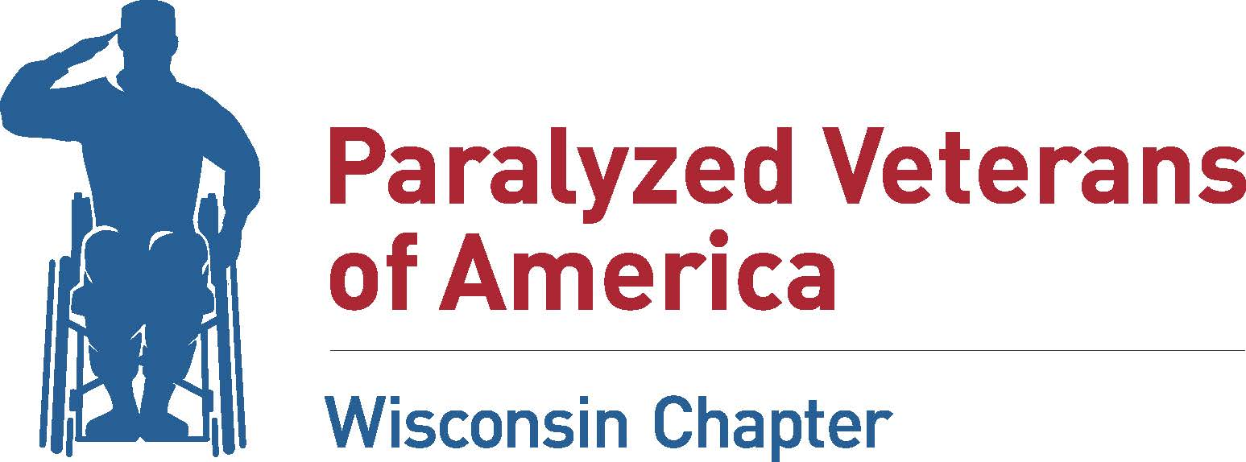

Hardship Grant Application

Name: __________________________________________________________________________________________

Address: _______________________________________________________________________________________

City: ___________________________________________________State: ________ Zip: ____________________

Phone: _______________________________ Email: ________________________________________________

Disability: _____________________________________________________________________________________

Service Connected: Y / N Age: ________ Married: Y / N # Dependents ___________

Total Household Income: __________________________

Primary Income Source: ___________________________

Additional Income Sources: ________________________

Available Personal/Family Assets:

Are you a current member of the Wisconsin Chapter PVA? Y/N

Amount Requested: _________________________________

Requested Assistance: _______________________________________________________________________

____________________________________________________________________________________________________

____________________________________________________________________________________________________

____________________________________________________________________________________________________
Have all VA Benefits, all state and federal governmental agency benefits, and/or benefits or funds from private entities, been exhausted prior to submitting this request? Y/N

What circumstances have led to this need? (This information may be provided in a separate letter.)
____________________________________________________________________________________________________

____________________________________________________________________________________________________

____________________________________________________________________________________________________

____________________________________________________________________________________________________

Date of last contact with your PVA National Service Officer: __________________________

I verify that the above information and any other information and/or documentation submitted to support my application for the Hardship Grant, is accurate to the best of my knowledge.

____________________________________________________________ ____________________________________
Signature Date

